INFOSYS SPRINGBOARD VIRTUAL INTERNSHIP
MODULE-3
GUEST ANALYSIS MODULE
Name: Shiven Pratap Singh
Project Name: HotelRevAI AI Driven Revenue Analysis for Hotels_Batch -13
1)After refreshing and loading the remaining data in Power BI, several additional columns were introduced in the Booking table to enrich the analysis. These included Source Type, Guest Type, Room Rate, Number of Bookings, and Customer Cluster.
Adding these fields provides deeper insights into booking behavior, customer segmentation, and revenue patterns, making the analysis more detailed and meaningful.
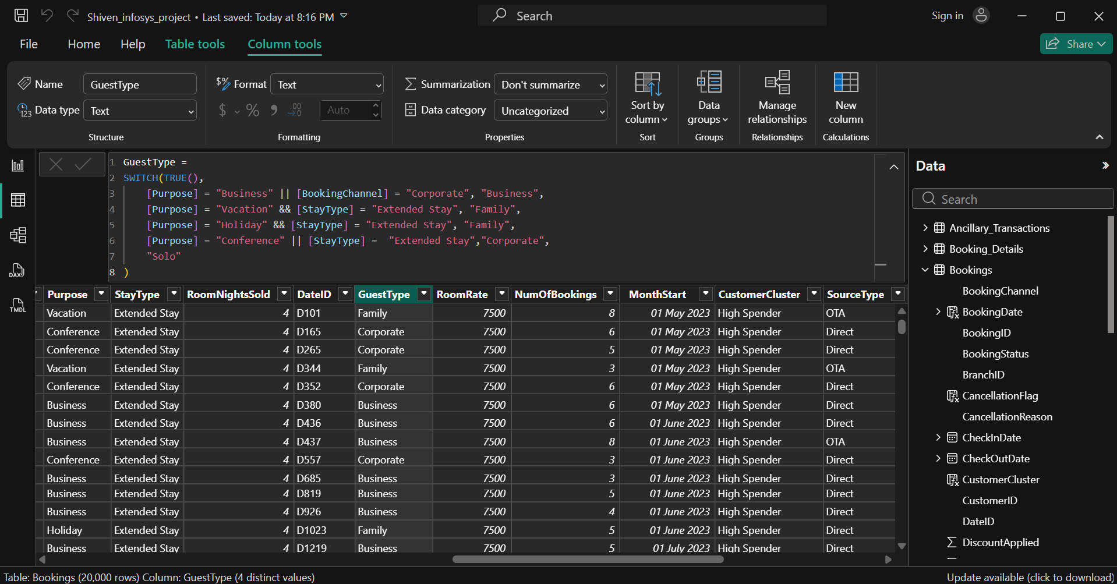

SourceType =
SWITCH(
'Bookings'[BookingChannel],
"Call Center", "Direct",
"Mobile App", "Direct",
"Website", "Direct",
"Travel Agent", "OTA",
"Other"
)
GuestType =
SWITCH(TRUE(),
[Purpose] = "Business" || [BookingChannel] = "Corporate", "Business",
[Purpose] = "Vacation" && [StayType] = "Extended Stay", "Family",
[Purpose] = "Holiday" && [StayType] = "Extended Stay", "Family",
[Purpose] = "Conference" || [StayType] = "Extended Stay","Corporate",
"Solo"
)
RoomRate = RELATED(Room[Price])
NumOfBookings =
CALCULATE(
COUNT(Bookings[BookingID]),
ALLEXCEPT(Bookings, Bookings[CustomerID])
)
CustomerCluster =
SWITCH(TRUE(),
[NumOfBookings] = 1 && [Revenue] < 5000, "First-Timer",
[NumOfBookings] >= 3 && [Revenue] < 15000, "Loyal Guest",
[Revenue] >= 15000, "High Spender",
"Other"
)

2) After that, a new table called TblGuests was created in Power BI. In this table, key scoring columns—Frequency Score, Spend Score, and Recency Score—were added.
These metrics help in evaluating customer behavior by analyzing how often guests book, how much they spend, and how recently they made a booking, enabling better segmentation and insights.

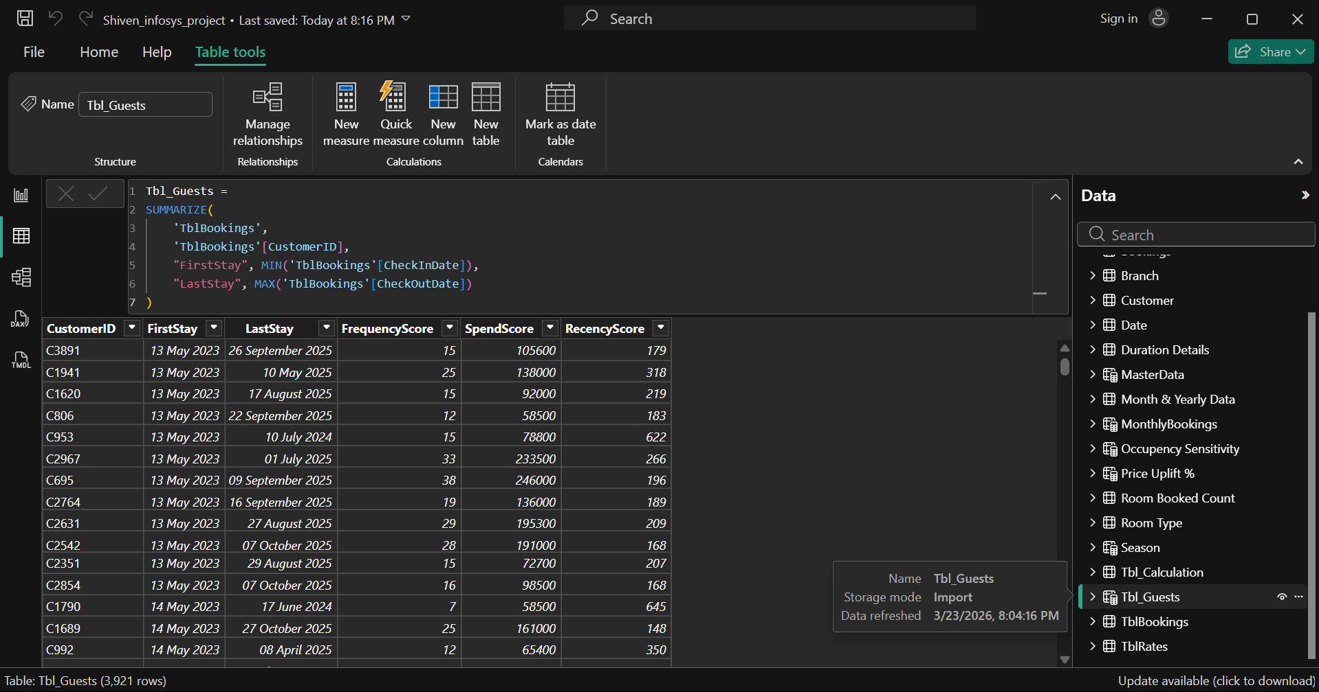
VISUALISATION
Guest Analysis:
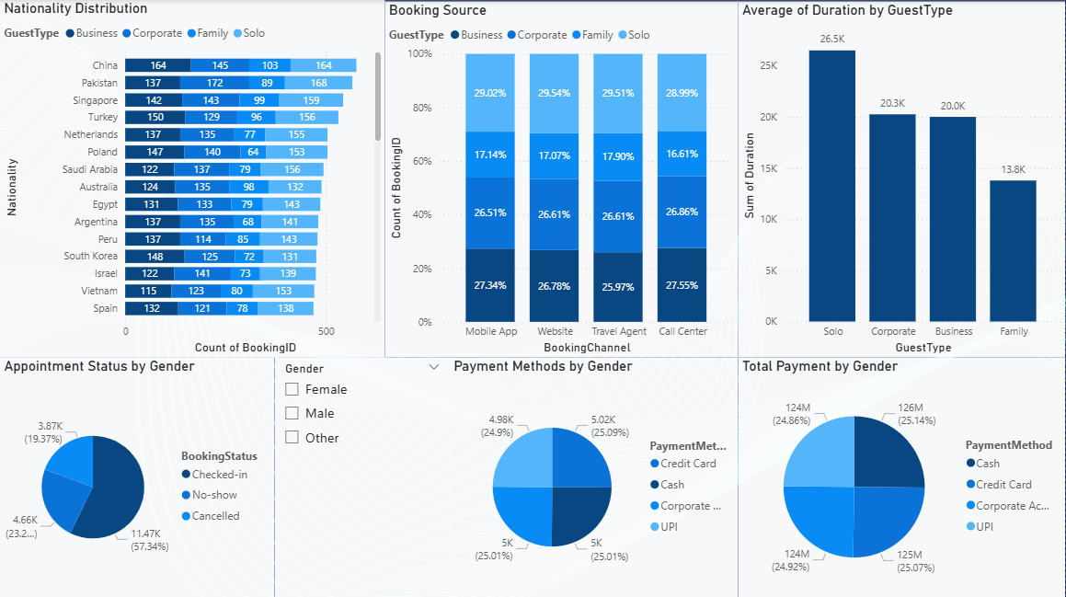
Scatter Chart (Based on sum of SpendScore, sum of FrequencyScore and CustomerID by RecencyScore and CustomerCluster):
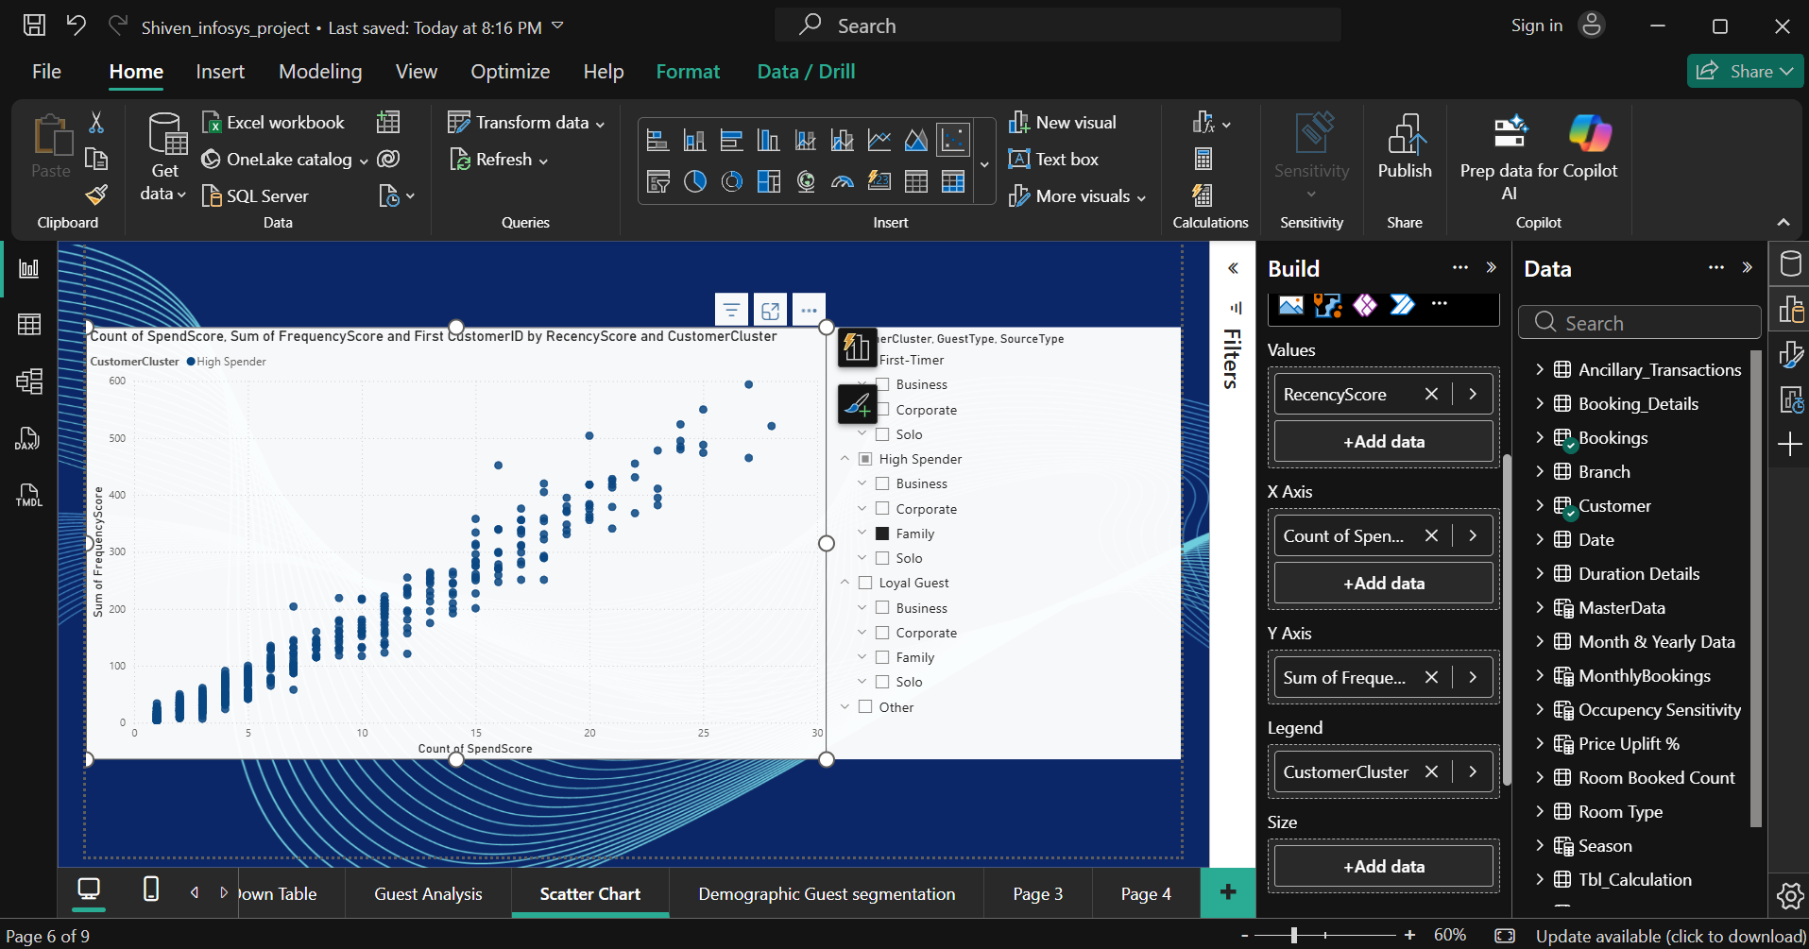
Demographic Guest Segmentation (Based on Nationality , CustomerCluster, SourceType, GuestType):
